Appendix:

Example data and expected input/output interfaces
Appendix Table. Example process parameters and elemental composition data.
Temperature (K) | P_{O2} (atm) | Si | Al | Ca | Fe | Au
1673 | 1.00E-10 | 0.203453971 | 0.037548758 | 0.143134737 | 0.009108574 | 0.00013
Continued table:
Cu | Pb | Sn | Sb | Ag | Br
0.169783823 | 0.000582949 | 0.002696138 | 0.002623269 | 0.002404664 | 0.008744231

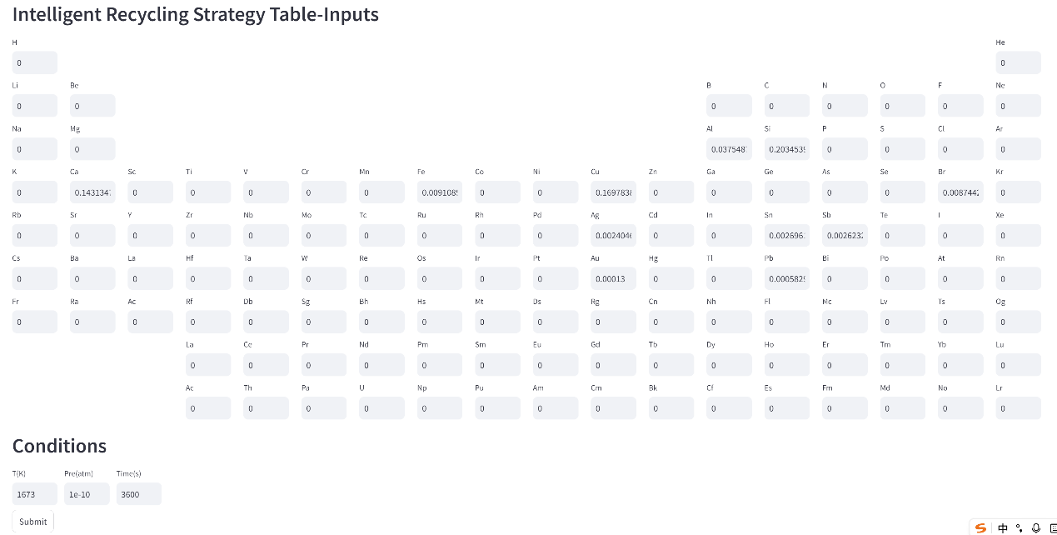
Appendix Fig. 1 Expected input interface of IRST.
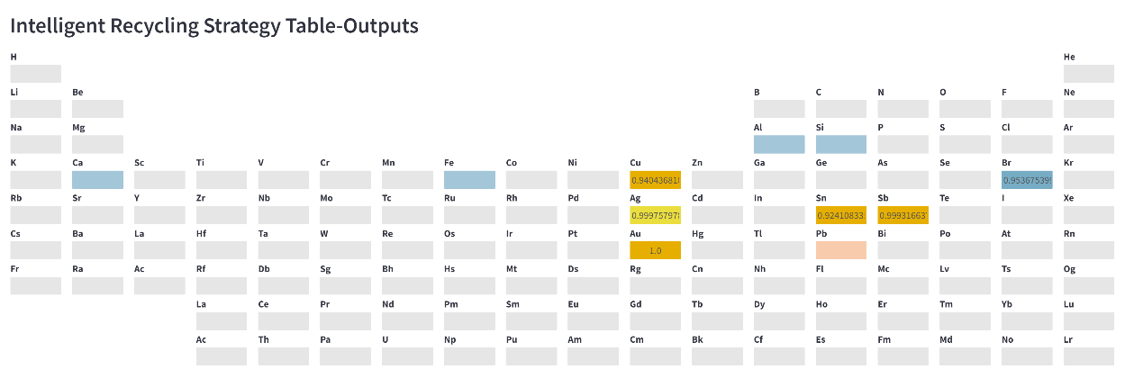
Appendix Fig. 2 Expected output interface of IRST.

